[ Insert official UPAEP logo ]
UPAEP · Decanato de Ingenierías
EVIDENCE — SPR-T2
Sprint Review preparation and evidence compilation
SmartGreenAI: Cilantro Crop

1. Task information
Task ID | SPR-T2
User Story | Sprint-level task
Sprint | Sprint 2 (2026-09-21 – 2026-10-09)
Week | Week 3
Responsible | Jorge Velez Delgado + Alexis Enrique Valle Parra
Peer reviewer | Whole team
Planned / actual hours | 2 h / 2 h (1 h Jorge, 1 h Alexis)
Completed on | October 8, 2026
Status | Done

2. Task description
Collect the evidence of every task in one folder, update the board, prepare the demo script and the Sprint 2 summary for the Review.

3. Completion conditions
✓ Condition 1: Evidence of every task is in the Sprint 2 folder.
How it was verified: Evidence of every Sprint 2 task is in evidence/Sprint 2/Evidence/<User Story>/ with the name <TaskID>_<Task_Name>; the index below lists the 36 documents and the number of attached files collected for each.
Sprint 2 evidence index
Task | Title | Responsible | Evidence file | Attachments | Status
US01C-T1 | Connect the login form to the authentication service | Alexis Enrique Valle Parra | US-01-C/US01C-T1_Connect_Login_Form_Authentication_Service.docx | 8 | collected
US01C-T2 | Implement role-based access (RBAC) and redirection | Alexis Enrique Valle Parra | US-01-C/US01C-T2_Implement_Role-Based_Access_RBAC_Redirection.docx | 10 | collected
US01C-T3 | Build and run the permission matrix test | Alexis Enrique Valle Parra | US-01-C/US01C-T3_Build_Run_Permission_Matrix_Test.docx | 2 | collected
US01C-T4 | Test invalid credentials and unauthorized access | Alexis Enrique Valle Parra | US-01-C/US01C-T4_Test_Invalid_Credentials_Unauthorized_Access.docx | 6 | collected
US06-T1 | Design the IoT-to-cloud data flow and message format | Vicente Rocha Alfaro | US-06/US06-T1_Design_IoT-To-Cloud_Data_Flow_Message.docx | 2 | collected
US06-T2 | Configure the cloud service and device authentication | Vicente Rocha Alfaro | US-06/US06-T2_Configure_Cloud_Service_Device_Authentication.docx | 6 | collected
US06-T3 | Implement measurement sending from the device (or simulator) | Vicente Rocha Alfaro | US-06/US06-T3_Implement_Measurement_Sending_Device_Simulator.docx | 5 | collected
US06-T4 | Handle connection failures | Vicente Rocha Alfaro | US-06/US06-T4_Handle_Connection_Failures.docx | 3 | collected
US06-T5 | End-to-end transmission test | Vicente Rocha Alfaro | US-06/US06-T5_End-To-End_Transmission_Test.docx | 4 | collected
US07-T1 | Design the measurement data model | Oscar Abraham Talavera Nava | US-07/US07-T1_Design_Measurement_Data_Model.docx | 5 | collected
US07-T2 | Create the database schema | Oscar Abraham Talavera Nava | US-07/US07-T2_Create_Database_Schema.docx | 6 | collected
US07-T3 | Implement the storage service | Oscar Abraham Talavera Nava | US-07/US07-T3_Implement_Storage_Service.docx | 6 | collected
US07-T4 | Implement history queries | Oscar Abraham Talavera Nava | US-07/US07-T4_Implement_History_Queries.docx | 5 | collected
US07-T5 | Test storage and retrieval | Oscar Abraham Talavera Nava | US-07/US07-T5_Test_Storage_Retrieval.docx | 4 | collected
US08-T1 | Write the API specification | Carlos Ramirez Mendoza | US-08/US08-T1_API_Specification_SmartGreenAI.docx | 0 | collected
US08-T2 | Set up the API project and security layer | Carlos Ramirez Mendoza | US-08/US08-T2_Set_Up_API_Project_Security.docx | 3 | collected
US08-T3 | Implement measurement endpoints | Carlos Ramirez Mendoza | US-08/US08-T3_Implement_Measurement_Endpoints.docx | 0 | collected
US08-T4 | Implement web application endpoints | Carlos Ramirez Mendoza | US-08/US08-T4_Implement_Web_Application_Endpoints.docx | 1 | collected
US08-T5 | Standardize validation and error responses | Carlos Ramirez Mendoza | US-08/US08-T5_Standardize_Validation_Error_Responses.docx | 1 | collected
US08-T6 | API test collection | Carlos Ramirez Mendoza | US-08/US08-T6_API_Test_Collection.docx | 0 | collected
US10-T1 | Define the threshold data model and default values | Jorge Velez Delgado | US-10/US10-T1_Define_Threshold_Data_Model_Default.docx | 4 | collected
US10-T2 | Design the threshold configuration screen | Jorge Velez Delgado | US-10/US10-T2_Design_Threshold_Configuration_Screen.docx | 2 | collected
US10-T3 | Implement create/update logic with validation | Jorge Velez Delgado | US-10/US10-T3_Implement_Create_Update_Logic_Validation.docx | 6 | collected
US10-T4 | Connect the screen to the API | Jorge Velez Delgado | US-10/US10-T4_Connect_Screen_API.docx | 6 | collected
US10-T5 | Test threshold configuration | Jorge Velez Delgado | US-10/US10-T5_Test_Threshold_Configuration.docx | 4 | collected
US14-T1 | Define actuator states and data | Oscar Abraham Talavera Nava | US-14/US14-T1_Define_Actuator_States_Data.docx | 4 | collected
US14-T2 | Implement the current-status query | Oscar Abraham Talavera Nava | US-14/US14-T2_Implement_Current-Status_Query.docx | 3 | collected
US14-T3 | Build the actuator status panel | Oscar Abraham Talavera Nava | US-14/US14-T3_Build_Actuator_Status_Panel.docx | 2 | collected
US14-T4 | Test actuator status visualization | Oscar Abraham Talavera Nava | US-14/US14-T4_Test_Actuator_Status_Visualization.docx | 9 | collected
US25-T1 | Define the device registry model | Alexis Enrique Valle Parra | US-25/US25-T1_Define_Device_Registry_Model.docx | 5 | collected
US25-T2 | Design the registration screens | Alexis Enrique Valle Parra | US-25/US25-T2_Design_Registration_Screens.docx | 4 | collected
US25-T3 | Implement register, edit and deactivate | Alexis Enrique Valle Parra | US-25/US25-T3_Implement_Register_Edit_Deactivate.docx | 6 | collected
US25-T4 | Generate device credentials | Alexis Enrique Valle Parra | US-25/US25-T4_Generate_Device_Credentials.docx | 5 | collected
US25-T5 | Test the registration flow | Alexis Enrique Valle Parra | US-25/US25-T5_Test_Registration_Flow.docx | 1 | collected
SPR-T1 | End-to-end integration test | Whole team (facilitated by Jorge) | Sprint/Sprint2_SPR-T1_End-To-End_Integration_Test.docx | 7 | collected
SPR-T2 | Sprint Review preparation and evidence compilation | Jorge Velez Delgado + Alexis Enrique Valle Parra | Sprint/Sprint2_SPR-T2_Sprint_Review_Preparation_Evidence_Compilation.docx | 0 | this document
900,2500,1500,2860,800,800
✓ Condition 2: Board and burndown are updated.
How it was verified: The board was updated by the Scrum Master after each Monday meeting and the burndown reached 0 h at the end of Week 3 (checkpoints from the Sprint Review; chart below).
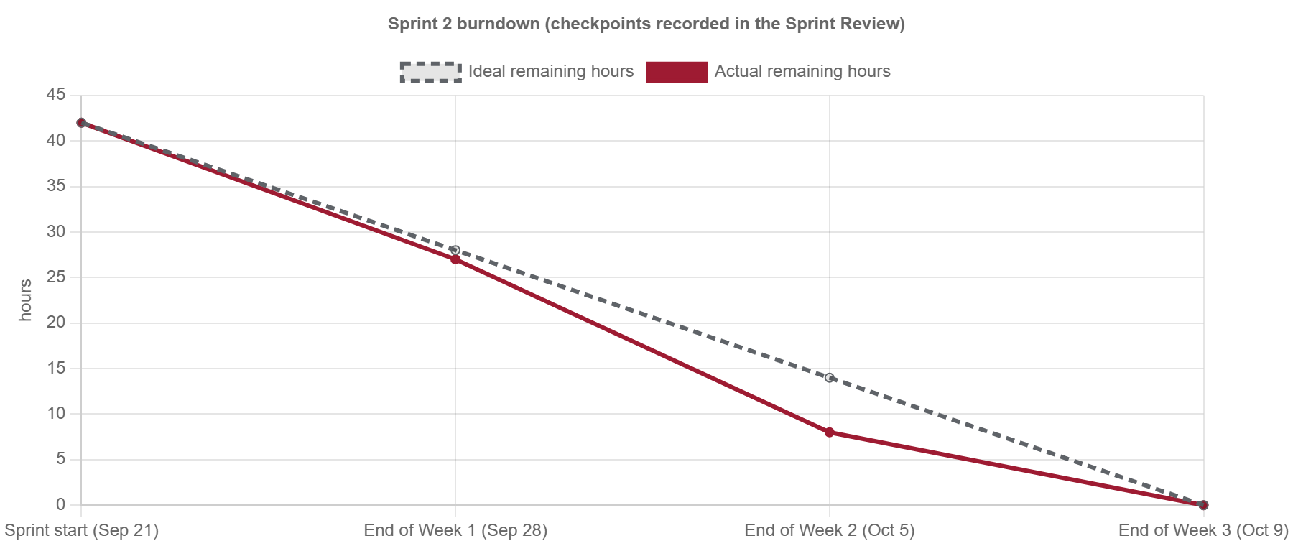
Figure SPR-T2-1. Sprint 2 burndown drawn from the Monday checkpoints recorded by the Scrum Master. (Sprint2_SPR-T2_Sprint_Review_Preparation_Evidence_Compilation_1.png)
✓ Condition 3: Demo script ready before the Sprint Review.
How it was verified: The demo script was ready before the Review (attached Sprint2_SPR-T2_Sprint_Review_Preparation_Evidence_Compilation_2.md).
Demo script (attached: Sprint2_SPR-T2_Sprint_Review_Preparation_Evidence_Compilation_2.md)
1. Sign in as Administrator → IoT devices: dev-node-01, its sensors and actuators (US-25); register a node and show the key shown once.
2. Start the simulator (npm run simulate -- --interval 10); show the delivery log (US-06).
3. Producer dashboard: sensor cards update with the new readings and their time (US-07).
4. Postman: POST /measurements and GET /sensors/SM-01/measurements?from&to (US-08), then the full collection run.
5. Administrator → Sensor thresholds: edit soil moisture, show validation and confirmation (US-10).
6. Actuator status panel with ON/OFF/OFFLINE (US-14).
7. Security: sign in with each role, show the redirections and a 403 (US-01-C).

✓ Condition 4: Evidence: Evidence folder and demo script ready before the Review.
How it was verified: Evidence folder and demo script ready before the Review.

4. Attached files
- Sprint2_SPR-T2_Sprint_Review_Preparation_Evidence_Compilation_1.png
- Sprint2_SPR-T2_Sprint_Review_Preparation_Evidence_Compilation_2.md

5. Traceability
Related requirements | All requirements of the sprint
Implementation | See docs/TRACEABILITY.md
Verification | See docs/TRACEABILITY.md

6. Sign-off
Role | Name | Date | Signature
Responsible | Jorge Velez Delgado + Alexis Enrique Valle Parra | October 8, 2026
Peer reviewer | Whole team | October 8, 2026
Product Owner acceptance | Alexis Enrique Valle Parra | October 8, 2026
Approval record: Sprint 2 Review & Delivery (October 9, 2026) — burndown table and "Product Owner accepted the seven user stories"; Daily Meeting 3: "Every member uploads the evidence of each task with the name <TaskID>_<Task_Name> to the Sprint 2 evidence folder before Thursday."

